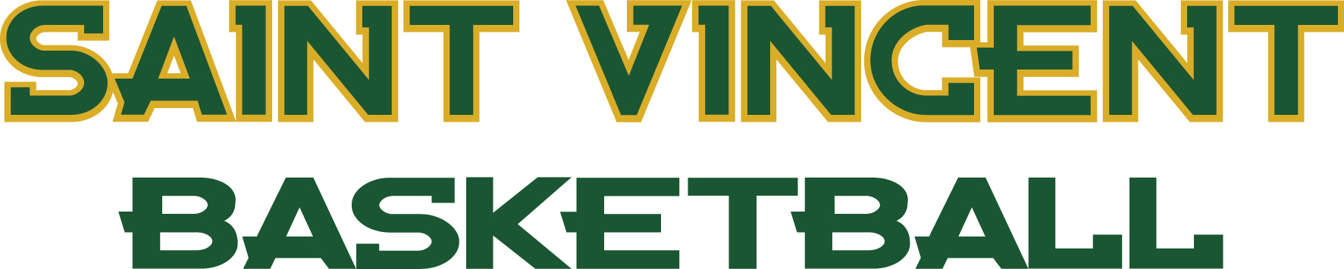

2020-21 Saint Vincent Men’s Basketball Roster
0 Syris Davila So. G 6-3 195 Woodbridge, Conn./Cortlandt V.R. Creed
1 Shemar Bennett Sr. F 6-6 195 Lauderhill, Fla./Nova
2 Enzo Fetsko Fr. G 5-10 155 Connellsville, Pa./Geibel Catholic
3 Jacob Johnson Fr. G 6-2 185 Mount Pleasant, Pa./Mount Pleasant
4 Reed Hipps So. G 6-0 185 Greensburg, Pa./Hempfield
5 Walter Bonds Sr. G 5-10 170 Pittsburgh, Pa./Bishop Canevin
10 Anthony Dillard Fr. F 6-4 205 Byron, Ga./Warner Robins
11 Kaleb Fields Fr. G 6-3 175 Latrobe, Pa./Sarasota
12 Sam Jacobyansky So. G 6-2 175 Wilmington, Ohio/Wilmington
13 Osyon Jones Fr. G 6-4 170 Orlando, Fla./Bishop Moore
14 Ishmael Davila Fr. G 6-2 180 Woodbridge, Conn./Amity High School
15 Caleb Jenkins So. G 5-10 165 Bruceton Mills, W.Va./South Harrison
20 Brayden Davis Fr. F 6-3 190 Elkins, W.Va./Elkins High School
23 Arguel Drotleff Fr. G 6-5 185 Sarasota, Fla./Cardinla Mooney
24 Adam Bosco Fr. G 5-7 160 Cape Coral, Fla./Mariner High School
25 Matias Bugallo Fr. G 5-8 148 Buenos Aires/IMG Academy
30 Corey Harden Fr. G 6-2 170 Henrico, Va./Varina High School
33 Nelson Etuk Fr. G 6-4 193 Roanoke, Va./North Cross

Coaching Staff
Head Coach – Terrance Smith
Assistant Coach – Ryan Wise
Assistant Coach – Kevin Fields
Athletic Trainer – Ben Varilek

0 – Syris Da-Vee-Ah
13 – Os-ee-on Jones
14 – Ishmael Da-Vee-Ah
23 – Ar-Gwel Drottleff
25 – Matias Bu-Ga-Low
33 – Nelson E-Tuck

